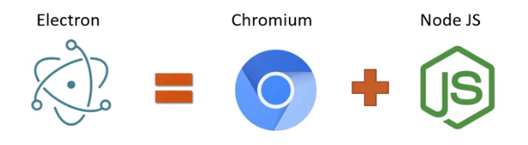
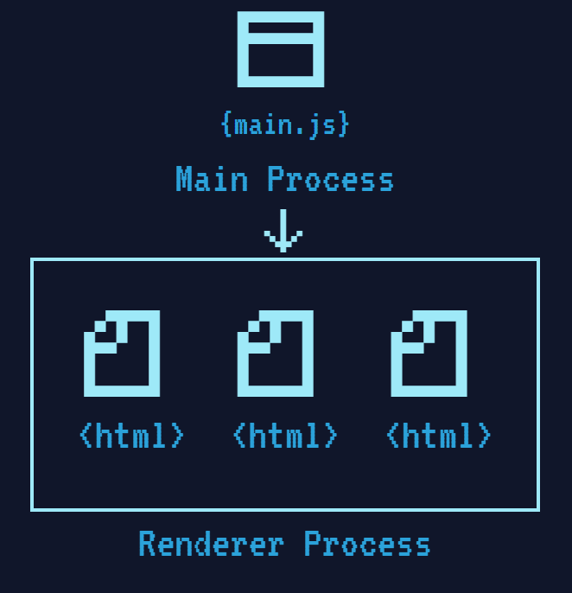
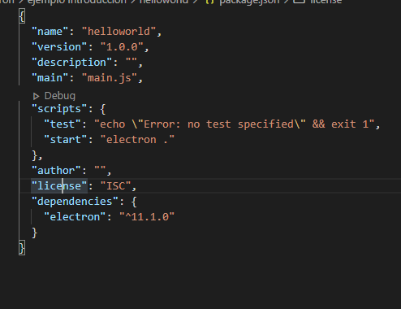
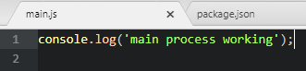
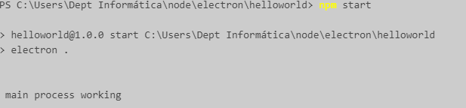
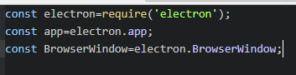
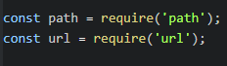
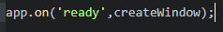
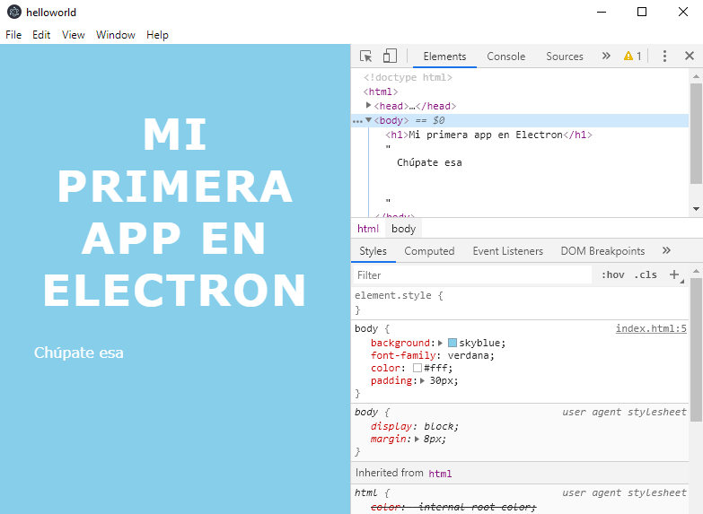
Electron

Electron is an open source framework. It enables the development of graphical desktop applications using client-side and server-side components originally developed for web applications: Node.js on the server side and Chromium as the interface.

Electron allows you to create desktop applications with pure JavaScript by providing a runtime system with powerful native APIs (operating system). You can see it as a variant of the Node.js runtime targeting desktop applications rather than web servers.

This does not mean that Electron is a JavaScript binding to Graphical User Interface (GUI) libraries. Instead, Electron uses web pages as a Graphical Interface, so you can also see it as a minimal Chromium browser, controlled by JavaScript.

There are several reasons why you might want to make a desktop application in node.js instead of a web application:
- web applications are browser dependent.
- access to files is more limited.
- network connectivity problems.

And why use web technologies to create desktop applications?
- the support community is broader and more accessible
- They are platform independent.
- you can take advantage of the knowledge of web programmers to generate them.
- Create desktop applications using popular web technologies (Javascript / CoffeeScript / ES6, HTML 5, CSS 3) as associated libraries (jQuery, React, Bootstrap, etc.)
- Freedom and homogeneity in the visual design of the application
- Automatic Updates
- Native menus
- Depuration

We can install electron as a development dependency, executing from the root directory of our project:

npm install --save-dev electron

In this case an entry is created in our package.json, indicating this dependency in "devDependencies".

It can also be installed locally in this way:

npm install --save electron

In this case an entry is created in our package.json, indicating this dependency in "dependencies". We will use this form in our examples and exercises.

It can also be installed globally:

npm install -g electron

To see the installation process we can add the –verbose option

npm install --save - verbose electron

Basic Architecture

A basic Electron application has two types of processes running concurrently: Main and Renderer.

Main Process

This process is the entry point of Electron and is responsible for managing the web pages that we are going to show from our application by displaying them in browser windows.

The main process provides a link point between the application and the operating system, and provides methods to call native API functions, such as menu events, notifications, and others related to interface handling.
An Electron application can only have one main process.

Renderer Process

The renderer process is the instance that displays the content of our web application. Therefore it has access to the API of our DOM and the browser.

Unlike the main process, there can be more than one renderer process in our application. Each browser window running the main process has its own independent renderer process, and, similar to the Chromium architecture, there is the guarantee that if one process crashes, the remaining ones continue to function unaffected.

The main and renderer processes live within the Node.js ecosystem, therefore both have access to its API and can perform low-level operations, such as accessing the file system.

The app object and the BrowserWindow class

Electron controls the life cycle of the application through the app object that has listeners to various events that I can associate with functions or routines when they are fired.

To create the windows that will host the web pages of the renderer processes, we must create BrowserWindow instances in our main process and pass the location of the HTML file that we want to display. It can be a local or remote location.

Hello World in Electron

As far as development goes, an Electron app is essentially a Node.js app. We would start with a package.json file identical to the one that would be used in a Node.js module. A very basic Electron application might have the following folder structure:

Hello World/
├── package.json
├── main.js
└── index.html

Contents of index.html:

<!DOCTYPE html>
<html>
<head>
<style>
body{background:skyblue;font-family:verdana;colour:#fff;padding:30px;}
h1{font-size:48px;text-transform:uppercase;letter-spacing:2px;text-align:center;}
</style>
</head>
<body>
<h1>My first app in Electron</h1>
Beat that!!!
</body>
</html>

We will have to modify the package.json

Main.js content:

First, to test, we write a log to test if electron works

we execute npm start

Now we are going to create a window. We delete the previous log.
First we import the electron module and then we will need an application itself and a window
We add two modules, one to work with routes and another with url

We need to create the window and for this we are going to define a function. First the variable in the module, and in the function there is chicha: but in summary we define properties to load the view of the application, which is the index.html that we will create shortly. We define that it is a file and that it is necessary to write a double slash in front of the protocols.

function createWindow() {
let win=new BrowserWindow( {
webPreferences:{
nodeIntegration:true
}
}

);
win.loadURL(url.format({
pathname:path.join(__dirname,'index.html'),
protocol:'file',
slashes:true
}));

win.webContents.openDevTools();
win.on('closed',() =>{
win=null;
})

}

The line

win.webContents.openDevTools();

It is only used to open the debugging windows of the browser, normally we will not have it.

With win.loadURL we load the html file that will define the interface. Another alternative way to write the above statement is

win.loadURL (`file: //$ {__ dirname}/ app / index.html`)

You can also use the loadFile function.

win.loadFile('index.html')

loadUrl allows, however, to load files on another IP or web pages

win.loadURL ('https://github.com')
win.loadURL ('http://127.0.0.1/test/')
win.on ('closed', () => {win = null;}) removes the reference to the window object, normally you would save the windows in a vector if your application supports multiple windows, this is when you should delete the corresponding item.

Then we will create the window when the application throws the ready event

The full main.js

const electron=require('electron');
const app=electron.app;
const BrowserWindow=electron.BrowserWindow;

const path = require('path');
const url = require('url');

function createWindow() {
let win=new BrowserWindow( {
webPreferences:{
nodeIntegration:true
}
}

);
win.loadURL(url.format({
pathname:path.join(__dirname,'index.html'),
protocol:'file',
slashes:true
}));

win.webContents.openDevTools();
win.on('closed',() =>{
win=null;
})

}

app.on('ready',createWindow);

We execute npm start

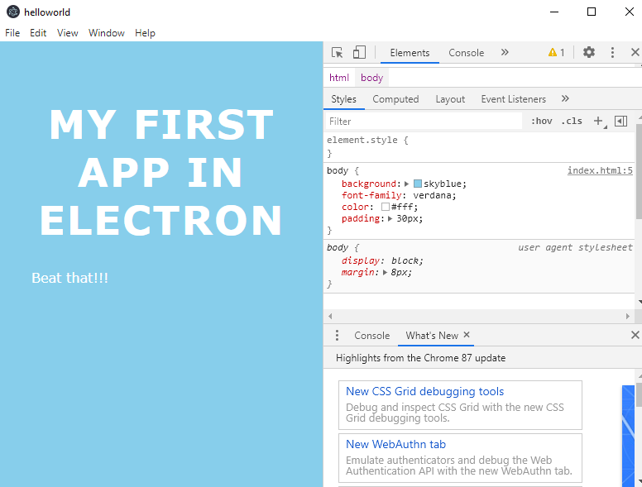

NOTE: if a security warning appears, deactivate it with the following instruction
process.env ['ELECTRON_DISABLE_SECURITY_WARNINGS'] = 'true';

